CFS Phone Cost and Equipment Summary
Based on the 2022 Affiliated Com-Net agreement, Hawk iSolutions proposal, and Mar. 2026 invoice
Monthly recurring charge | Documented one-time charges | Best current reading
$257.05/month in the signed 2022 Affiliated agreement.  A Mar. 2026 invoice shows $274.39/month currently billed. | Affiliated agreement: $793.44.  Hawk proposal: $3,793.44, including $3,000 deployment/programming. | This looks more like an ongoing hosted-service arrangement than rent-to-own.  The documents do not show automatic transfer of ownership after 36 months.

Key points
• The signed Affiliated Com-Net agreement shows a 3-year term and a monthly service-plan total of $257.05.
• That agreement also lists one-time installation and activation fees totaling $793.44.
• A separate Hawk iSolutions configuration sheet shows the same monthly amount but higher up-front charges because it includes a $3,000 deployment/programming line.
• The contract language says monthly charges begin at installation/service inception, so total paid to date depends on the actual billing start date and any partial first month.
• The Mar. 2026 invoice indicates monthly charges continued after the initial 36-month term, which suggests the term was a service commitment rather than a clear rent-to-own schedule.
• The provider-managed voice/router design appears to have imposed routing restrictions that make maintenance, network changes, and ISP transitions more difficult for CFS.
Estimated recurring total paid | Why monthly charges may still continue  • Hosted PBX / cloud voice service  • DID numbers and SIP/voice paths  • E911 and regulatory fees  • Licensing, support, and maintenance  • Possible continuing device-related service charges  Recommended next check: Obtain the full executed agreement, equipment schedule, and a current invoice detail before assuming CFS owns the phones/router or that monthly device charges should have ended after month 36.
  Scenario | Months | Total
  If full monthly billing began Sep. 2022 and continued through Mar. 2026 | 43 | $11,053.15
  If the first full month billed was Oct. 2022 and continued through Mar. 2026 | 42 | $10,796.10

Illustrative UniFi Talk comparison
Estimated cost comparison assuming 2 outside numbers and 10 extensions:
Option | Up-front cost | Monthly cost | 42-43 month result
Affiliated Com-Net  (documented paid to date) | $793.44 documented  one-time charges | $257.05 / month | $11,590-$11,847 paid to date
UniFi Talk  (estimate) | $1,489  10 phones + 1 console | $19.98 / month  2 numbers | $2,328-$2,348 over the same period
Estimated savings  with UniFi Talk | - | - | $9,261-$9,498 less
Notes: UniFi Talk estimate assumes 10 desk phones at about $129 each, one modest UniFi console at about $199, and 2 outside numbers at $9.99 each per month. It does not include any separately purchased migration labor or outside support.
The current provider arrangement also appears to have enforced routing constraints through its managed voice/router design, which has complicated maintenance, network additions or updates, and changing ISPs.

Prepared for Bret Blackford | March 25, 2026

2022 Affiliated Com-Net signed service agreement
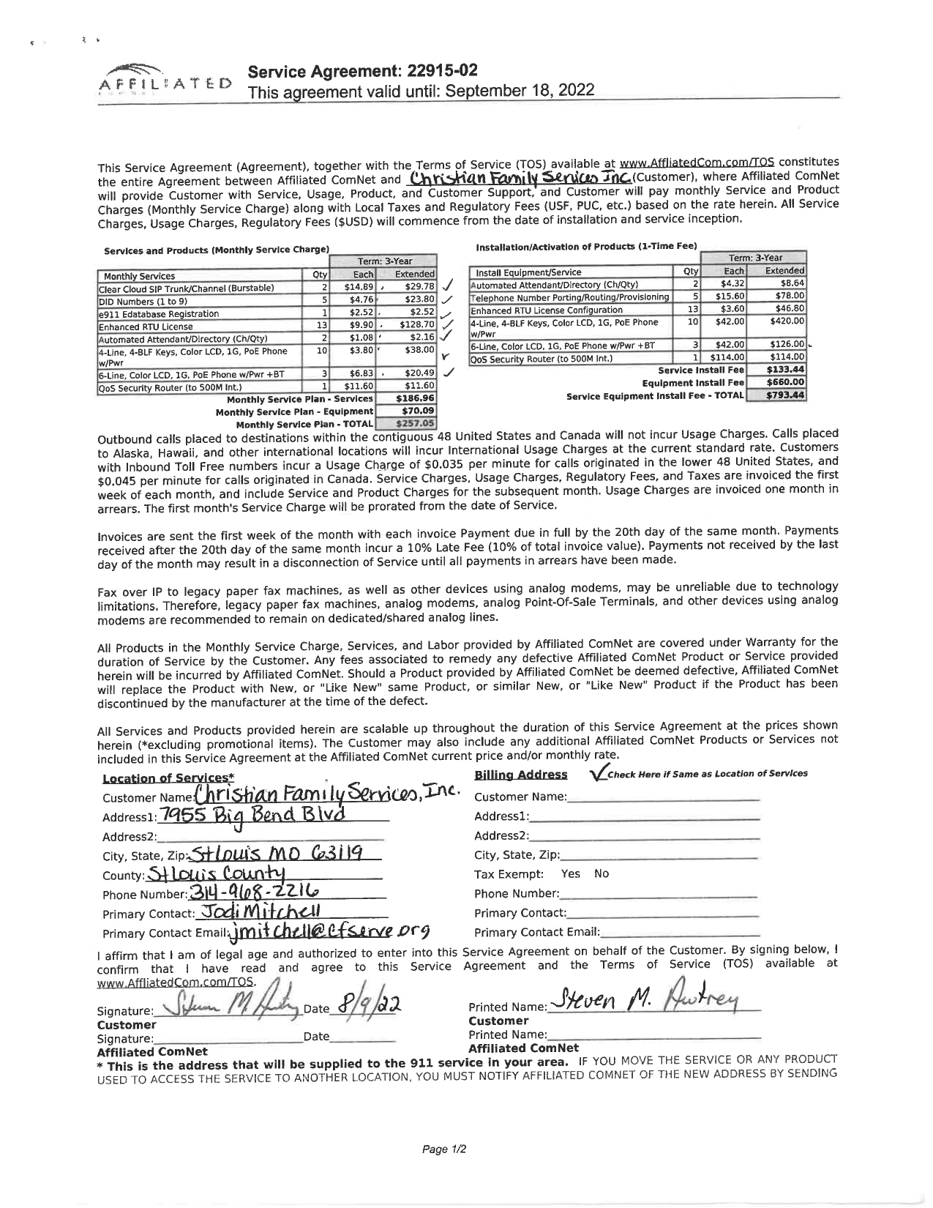

2022 Hawk iSolutions configuration / pricing sheet
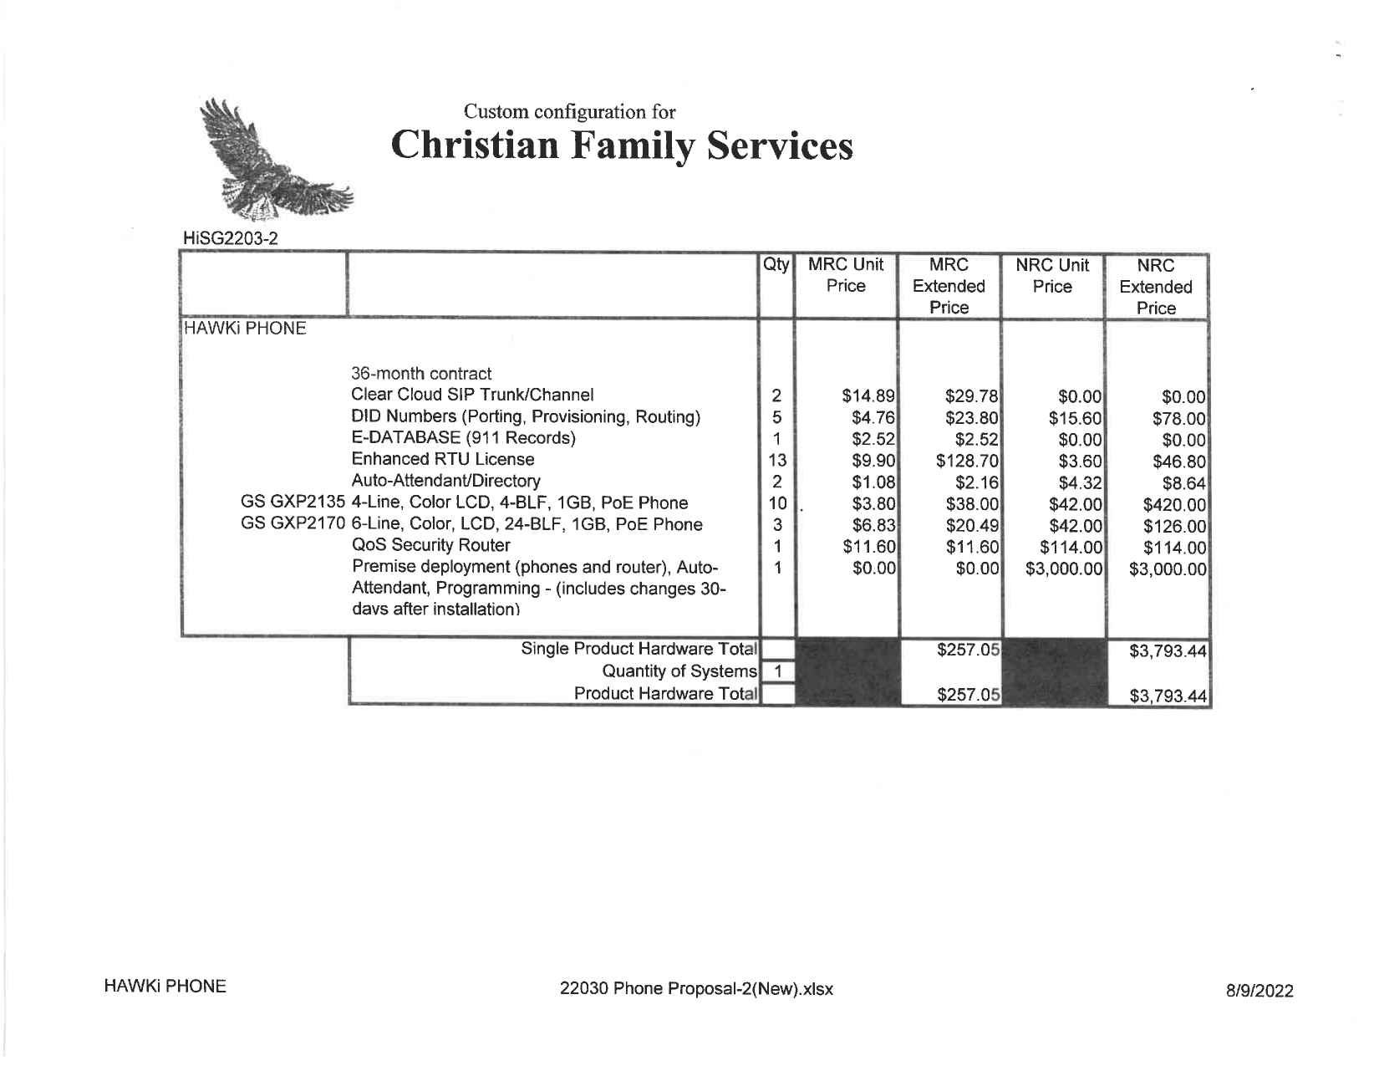

March 2026 Affiliated Com-Net invoice
