Christian Family Services (CFS)
2026 IT Environment Review
Prepared for Eric McPherson, Executive Director
Prepared by M. Bret Blackford, Board of Trustees
March 2026

Christian Family Services (CFS) is a small non-profit located in Webster, Missouri and CFS exists to walk alongside people and families in crisis or transition, offering Christian counseling, pregnancy and parenting support, child-placement and family-care services, and practical assistance aimed at strengthening relationships, protecting children, and helping families flourish. This aligns with the site’s recurring themes of trusted guidance, healthy relationships, and flourishing life.

Purpose: document the current-state CFS IT environment, identify material risks or constraints, and outline practical next steps for a more manageable, supportable, and flexible architecture.

This report grew out of a request to help clean up the second-floor IT closet. Before physical cleanup could be done safely, the environment first needed to be identified and documented so that critical equipment or dependencies were not disturbed.

Table of Contents
Executive Summary 4
At-a-Glance Findings 4
1. Scope and Context 4
2. Application Environment 5
3. Current Infrastructure and Topology 5
Known / Observed Hardware 5
Simplified Current-State Diagram 6
4. Principal Issues and Risks 6
Limited visibility and fragmented control 6
WAN-edge dependency on legacy design choices 6
Bandwidth bottleneck at the core switch 6
Telephony dependency is not yet narrow enough 6
Support responsibilities are split across several parties 6
Residual local infrastructure risk 6
5. Support Model and Current Costs 7
6. Recommendations 7
Recommendation 1: Freeze ad hoc changes until the dependency map is confirmed. 7
Recommendation 2: Move toward a customer-controlled UniFi-based edge and switching platform. 7
Recommendation 3: Narrow and isolate telephony dependencies. 7
Recommendation 4: Replace the apparent 100 Mbps switching bottleneck. 7
Recommendation 5: Treat the server and identity environment as Phase 2. 7
Recommendation 6: Clarify governance over outsourced IT. 7
Suggested phased roadmap 8
Attachment A - Source Highlights 8
Attachment B - Decision Notes for Eric McPherson 8
Supplemental Attachments – following pages below 9
Attachment A 10
Attachment B 11
Attachment C 12
Attachment D.1 13
Attachment D.2 14
Attachment D.3 15
Attachment D.4 16
Attachment E.1 17
Attachment F.1 18
Attachment F.2 18
Attachment F.3 19
Attachment G 20

Executive Summary
CFS appears to operate with a largely cloud-based application environment for core business functions, including browser-based line-of-business systems, QuickBooks Online, and likely Microsoft 365 services for email and file collaboration. That is encouraging because it reduces dependence on heavy on-premises application infrastructure.
At the same time, important local infrastructure still remains in place. Based on the materials reviewed, the Cisco ASA 5506-X is currently acting as the primary firewall and routing device, the MikroTik RouterBoard remains involved in the phone environment, the Netgear FS728TP switch appears to be a 10/100 Mbps bottleneck, and the Dell PowerEdge R720 still supports local services such as domain authentication, file share, and print services.
The central architectural concern is not simply aging hardware. It is that routing, telephony dependencies, and support responsibilities appear to be split across multiple vendors and devices in a way that reduces visibility, complicates troubleshooting, and makes future change harder than it should be for an organization of this size.
The most practical near-term path is a phased modernization. Phase 1 should focus on documenting the remaining dependencies, replacing the network edge router and core switch with a customer-controlled, cloud-managed platform, and narrowing phone-specific legacy dependencies. Phase 2 can then address server, identity, and file-share modernization once network visibility and control have improved.
In summary, I recommend (ref. §6 below):
- Review findings with Kevin Romain to get agreement
- Work with telephone provider Affiliated Com-Net and move IP routing away from telephone-specific equipment and onto a standard edge router (possibly UniFi)
- Replace current 10/100 Mbps network switch with faster Gigabit switch (possibly UniFi)
- Consider telephone expense and if a change is advantageous
- Consider migrating remaining local server functions to Microsoft 365 / Azure services, if a separate dependency review supports that path

At-a-Glance Findings
Area | Observation | Implication
Applications | Most key applications appear cloud-based. | Network simplification is feasible.
WAN edge | Spectrum router is bridged and the Cisco ASA appears to handle routing. | ISP flexibility and visibility are reduced.
Switching | Netgear FS728TP appears limited to 100 Mbps. | Local traffic is bottlenecked.
Telephony | MikroTik and Grandstream phone path remain part of the environment. | Phone dependencies must be documented before cutover.
Support model | Responsibilities are split across multiple vendors. | Troubleshooting and decision-making are fragmented.
Server | Dell PowerEdge R720 still appears to provide local infrastructure services. | Server/identity modernization should follow network cleanup.

1. Scope and Context
This review is based on material gathered in March 2026, including network observations, a Fing scan, email exchanges with Kevin Romain and CFS staff, cost and support notes, and prior application-environment summaries.
The work was intended first to establish a safe understanding of the current environment before any cleanup, disconnection, or redesign effort. The report therefore emphasizes current-state documentation, architectural concerns, and decision-ready recommendations rather than a final migration design.

2. Application Environment
The available evidence suggests that CFS has already moved much of its business application footprint to cloud-hosted platforms. That is a major strength. It reduces reliance on local application servers and makes future network modernization less risky than it would be in a heavily on-premises environment.
Observed applications or platforms include ICANotes, Inovalon / Provider Cloud, FocusEDI, Silo, Dashlane, QuickBooks Online, and likely Microsoft 365 services such as Outlook and OneDrive.
Platform | Likely role | Note
ICANotes | Behavioral health EHR / charting | Appears browser-based.
Inovalon / Provider Cloud | Claims / eligibility / billing | Web portal access indicated.
FocusEDI | EDI / billing portal | Another browser-accessed portal.
Silo | Cloud portal | Purpose should be confirmed.
Dashlane | Password management | Positive control indicator.
QuickBooks Online | Accounting / bookkeeping | Suggests cloud-based accounting workflow.
Outlook / Microsoft 365 | Email / identity / collaboration | Strongly suggested by screenshots and admin-center references.
OneDrive | File storage / sharing | May reduce dependence on local file shares over time.
Main caution: although applications appear mostly cloud-based, local identity, file-share, print, and phone-related dependencies still seem to exist and should be treated as live until proven otherwise.

3. Current Infrastructure and Topology
The network appears to have grown incrementally as services were added by different parties. That is understandable, but the result is an environment with overlapping roles and limited end-to-end visibility.
The most consistent reading of the materials is that the Spectrum connection feeds a Spectrum router configured in bridge/pass-through mode, after which the Cisco ASA acts as the primary firewall and routing device for the local network. Downstream, the Netgear FS728TP switch distributes connectivity to office devices, Wi-Fi access points, server resources, and a phone-related path that involves a MikroTik RouterBoard and Grandstream phones.

Known / Observed Hardware
Component | Role | Known detail | Comment
Spectrum EN2251 modem | ISP handoff | Observed | Expected demarcation device.
Spectrum router | ISP gateway | Bridge/pass-through | Reduces customer control at WAN edge.
Cisco ASA 5506-X | Firewall / routing | LAN 192.168.44.1; WAN 96.35.181.122 | Appears to be primary local gateway.
Netgear FS728TP | Core switch | Appears 10/100 Mbps; 192.168.44.13 | Likely local bottleneck.
MikroTik RouterBoard | Phone-related role | 192.168.44.19 | Still appears tied to telephony.
Grandstream phones | Voice endpoints | Multiple devices observed | Some PCs may pass through phones.
TP-Link AP(s) | Wi-Fi access | Observed | Could be replaced in a unified platform.
Dell PowerEdge R720 | AD / file share / print | Observed | Treat as live infrastructure until dependency map is complete.

Simplified Current-State Diagram
Reference also Attachment B below
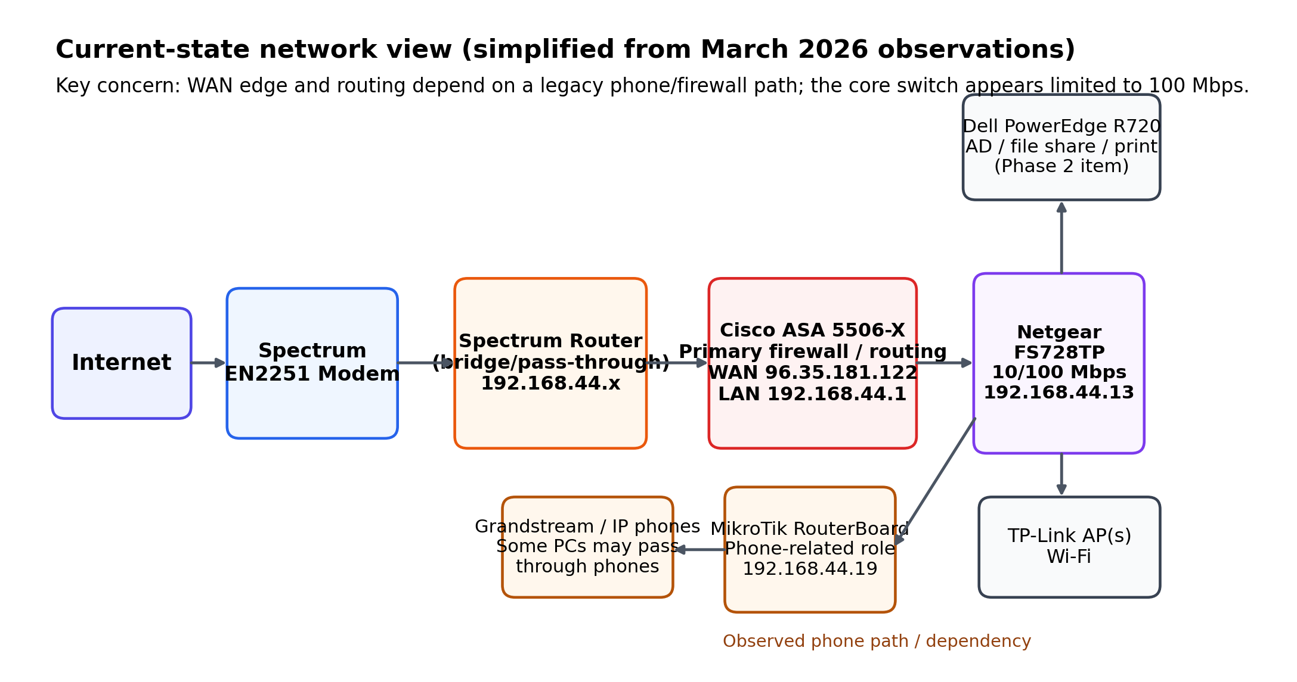
Figure 1. Simplified interpretation of the current-state network path based on March 2026 review materials.

4. Principal Issues and Risks

Limited visibility and fragmented control
There does not appear to be a single management plane that gives CFS a clear picture of routing, switching, wireless, phone dependencies, and attached devices. That makes troubleshooting slower and increases dependence on whichever vendor understands a given segment.

WAN-edge dependency on legacy design choices
Because the Spectrum router is bridged and the ASA appears to perform routing, the organization is more dependent than necessary on legacy firewall and telephony assumptions. This can make ISP changes, hardware refreshes, and troubleshooting more cumbersome.

Bandwidth bottleneck at the core switch
If the FS728TP is indeed operating as a 10/100 Mbps switch, then local traffic and uplink performance are constrained regardless of purchased internet speed or endpoint capability.

Telephony dependency is not yet narrow enough
The MikroTik and phone path appear to remain intertwined with the broader network. That does not mean the phones are wrong, but it does mean the dependency should be documented and, if possible, isolated so voice service does not dictate the rest of the architecture.

Support responsibilities are split across several parties
CFS appears to rely on Fix It Solutions, Hawk iSolutions, Affiliated Com-Net, and Spectrum. Outsourcing is entirely reasonable; the problem is the lack of a clearly documented architecture owner and change authority.

Residual local infrastructure risk
Cloud applications reduce risk, but local server-based identity, print, file share, and remote-support tooling still matter. Premature removal or reconfiguration of these dependencies could disrupt office operations.

5. Support Model and Current Costs
The known monthly and support figures below are useful for planning, but they should still be validated against current invoices and agreements before any contractual action is taken.
Vendor / service | Current understanding | Approx. cost | Comment
Fix It Solutions / Kevin Romain | Managed support plus special requests | $1,036.80 / month | Role should include clear architecture guidance and escalation path.
Affiliated Com-Net | Phone service / lines | $274.39 / month | Invoice support should be retained with contract file.
Hawk iSolutions | Special phone-related requests | $150 / hour as needed | Important for phone dependency questions.
Spectrum Business internet | Business internet service | $173.96 / month | Current design appears to constrain provider flexibility.
Microsoft 365 / email | No monthly amount confirmed | Unknown | CFS indicated licensing was purchased, but current recurring cost was not confirmed.

6. Recommendations

Recommendation 1: Freeze ad hoc changes until the dependency map is confirmed.
Before any cleanup or hardware removal, confirm the live routing path, the phone path, static IP usage, any server dependency, and whether any workstations still rely on phone pass-through or local file shares.

Recommendation 2: Move toward a customer-controlled UniFi-based edge and switching platform.
A modern UniFi gateway and managed switch would provide centralized visibility, easier documentation, and a more supportable platform for a small nonprofit. This recommendation is directionally sound, but the final design should wait until phone and server dependencies are fully documented.

Recommendation 3: Narrow and isolate telephony dependencies.
Determine exactly what the MikroTik and Grandstream environment require. If the current phones can remain while the core network is modernized, document that path clearly and isolate it as much as practical. If not, CFS can later evaluate whether continuing the current phone platform remains worthwhile.

Recommendation 4: Replace the apparent 100 Mbps switching bottleneck.
Even if no other change is approved immediately, replacing the core switch is a sensible step. That upgrade would remove an obvious performance constraint and improve visibility if done with a managed platform.

Recommendation 5: Treat the server and identity environment as Phase 2.
Do not assume the Dell R720 can be retired yet. Instead, plan a separate review of Active Directory, print, file share, remote support tools, backup posture, and readiness for SharePoint/OneDrive and Entra ID migration.

Recommendation 6: Clarify governance over outsourced IT.
CFS should have a documented architecture owner, change-approval path, and current-state diagram on file. Even when multiple vendors remain in place, someone must own the whole picture.

Suggested phased roadmap
Phase | Timeframe | Main work | Output
0 | Immediate | Complete current-state validation; collect static IP list; document phone/server dependencies. | Approved dependency map and cutover assumptions.
1 | Near term | Replace core switch and WAN edge with unified managed platform once dependencies are confirmed. | Central visibility, improved supportability, removal of 100 Mbps bottleneck.
2 | After Phase 1 stabilizes | Review server, Active Directory, file share, print, and remote-access tooling. | Server/identity modernization plan.
3 | Longer term | Complete SharePoint/OneDrive and Entra ID transition as appropriate. | Reduced on-premises dependency footprint.

Attachment A - Source Highlights
Selected points from reviewed materials are summarized below for convenience.
Kevin Romain indicated that the Spectrum device is in bridged mode, that the Cisco ASA currently serves as the primary firewall and routing device, and that the MikroTik is associated with the IP phone environment.
Kevin also identified on-premises dependencies that still matter: domain-level authentication, file share, print server, and IP phones.
CFS staff indicated approximate recurring costs of $1,036.80 per month for Fix It Solutions, $274.39 per month for Affiliated Com-Net phone service, and $173.96 per month for Spectrum internet.
CFS staff did not confirm a current monthly Microsoft 365 charge, noting instead that licensing had been purchased previously.
A phone-related document indicates a Hawk iSolutions 36-month configuration dated August 2022, and a separate Affiliated Com-Net service agreement image shows a validity date of September 18, 2022. Those dates suggest term questions should be rechecked carefully against the complete agreements and any renewal or notice language.

Attachment B - Decision Notes for Eric McPherson
The present environment is workable, but it appears more complex and vendor-dependent than necessary for CFS's size and mission.
The recommendation is not to make a disruptive all-at-once change. It is to complete a careful dependency review, then modernize the edge and switching platform in a controlled way.
The strongest immediate technical candidate for replacement is the apparent 100 Mbps core switch. The strongest immediate governance need is a clear architecture owner and current-state documentation on file.
Any decision about keeping or replacing the phone environment should follow confirmation of how tightly it is bound to the current routing path.

Supplemental Attachments – following pages below

Attachment A
On-line here - https://cfs.mxcoc.xyz/IT/CFS_ApplicationEnvironment.pdf

CFS Application Environment Summary
Working observations based on screenshots and application notes reviewed on March 20, 2026, including indications that Microsoft 365 / Outlook is used for email and OneDrive is used for file storage or sharing.
Overall assessment: CFS appears to rely primarily on cloud-hosted business applications rather than an on-premises application server. This is favorable for resiliency and future network migration work. Screenshots also indicate organizational email use tied to the cfsserve.org domain and QuickBooks Online for bookkeeping. Remaining questions center on the exact email platform, identity management, file storage, printing/scanning, and any legacy local dependencies.
Observed application environment
- Observed platforms include ICANotes, Inovalon / Provider Cloud, FocusEDI, Silo, Dashlane, and QuickBooks Online. The screenshots also indicate that Microsoft 365 / Outlook is used for email and that OneDrive is used for file storage and/or sharing.
- The visible use of the Microsoft 365 admin center, Outlook-related screens, and OneDrive suggests CFS is using Microsoft 365 services for communication, user account management, and at least some document storage / sharing.
Application | Likely role | Observation
ICANotes | Behavioral health EHR / charting | Browser-based access appears to be in use.
Inovalon / Provider Cloud | Claims, eligibility, and billing | Supports payer / claims processing through a web portal.
FocusEDI | EDI / billing portal | Another browser-accessed revenue-cycle tool.
Silo | Separate cloud portal | Observed as a web-based system; purpose should be confirmed.
Dashlane | Password management | Positive sign of centralized credential management.
QuickBooks Online | Bookkeeping / accounting | Browser tabs indicate QuickBooks Online is in use for accounting functions.
Organizational email | Email / communication | Screenshots show accounts using the cfsserve.org domain; exact email platform should be confirmed.

Why this is encouraging
- Core applications appear reachable through standard web browsers rather than a local application server.
- This reduces the risk that one aging on-site device would disable major operations.
- A cloud-centered stack should make future network cleanup or migration easier, assuming reliable internet.
- Dashlane suggests better password control than informal local storage, and the screenshots also point to an organized cloud-based credential environment.
Items still to confirm
- Whether user logins still depend on local Active Directory or another on-site identity system, even though most core applications appear cloud-based.
- Whether all shared files have been fully moved into OneDrive / Microsoft 365, or whether some data still lives on local PCs or a local file server / network share.
- Whether printers, scanners, or specialized devices depend on local server functions.
- Whether any shortcuts, mapped drives, or legacy processes still point to local resources rather than cloud services.
- How backups are handled for any remaining local data, and whether email / accounting data retention is managed entirely by cloud providers.

Bottom line: CFS appears to have a mostly cloud-based application environment, including browser-accessed business systems, Microsoft 365 / Outlook for email, OneDrive for file storage and/or sharing, and QuickBooks Online for bookkeeping. The next phase should focus on confirming whether any remaining local dependencies are tied to logins, printing/scanning, legacy shared folders, or other office resources.

Attachment B
On-line here - https://cfs.mxcoc.xyz/IT/CFS-CurrentState-.JPG
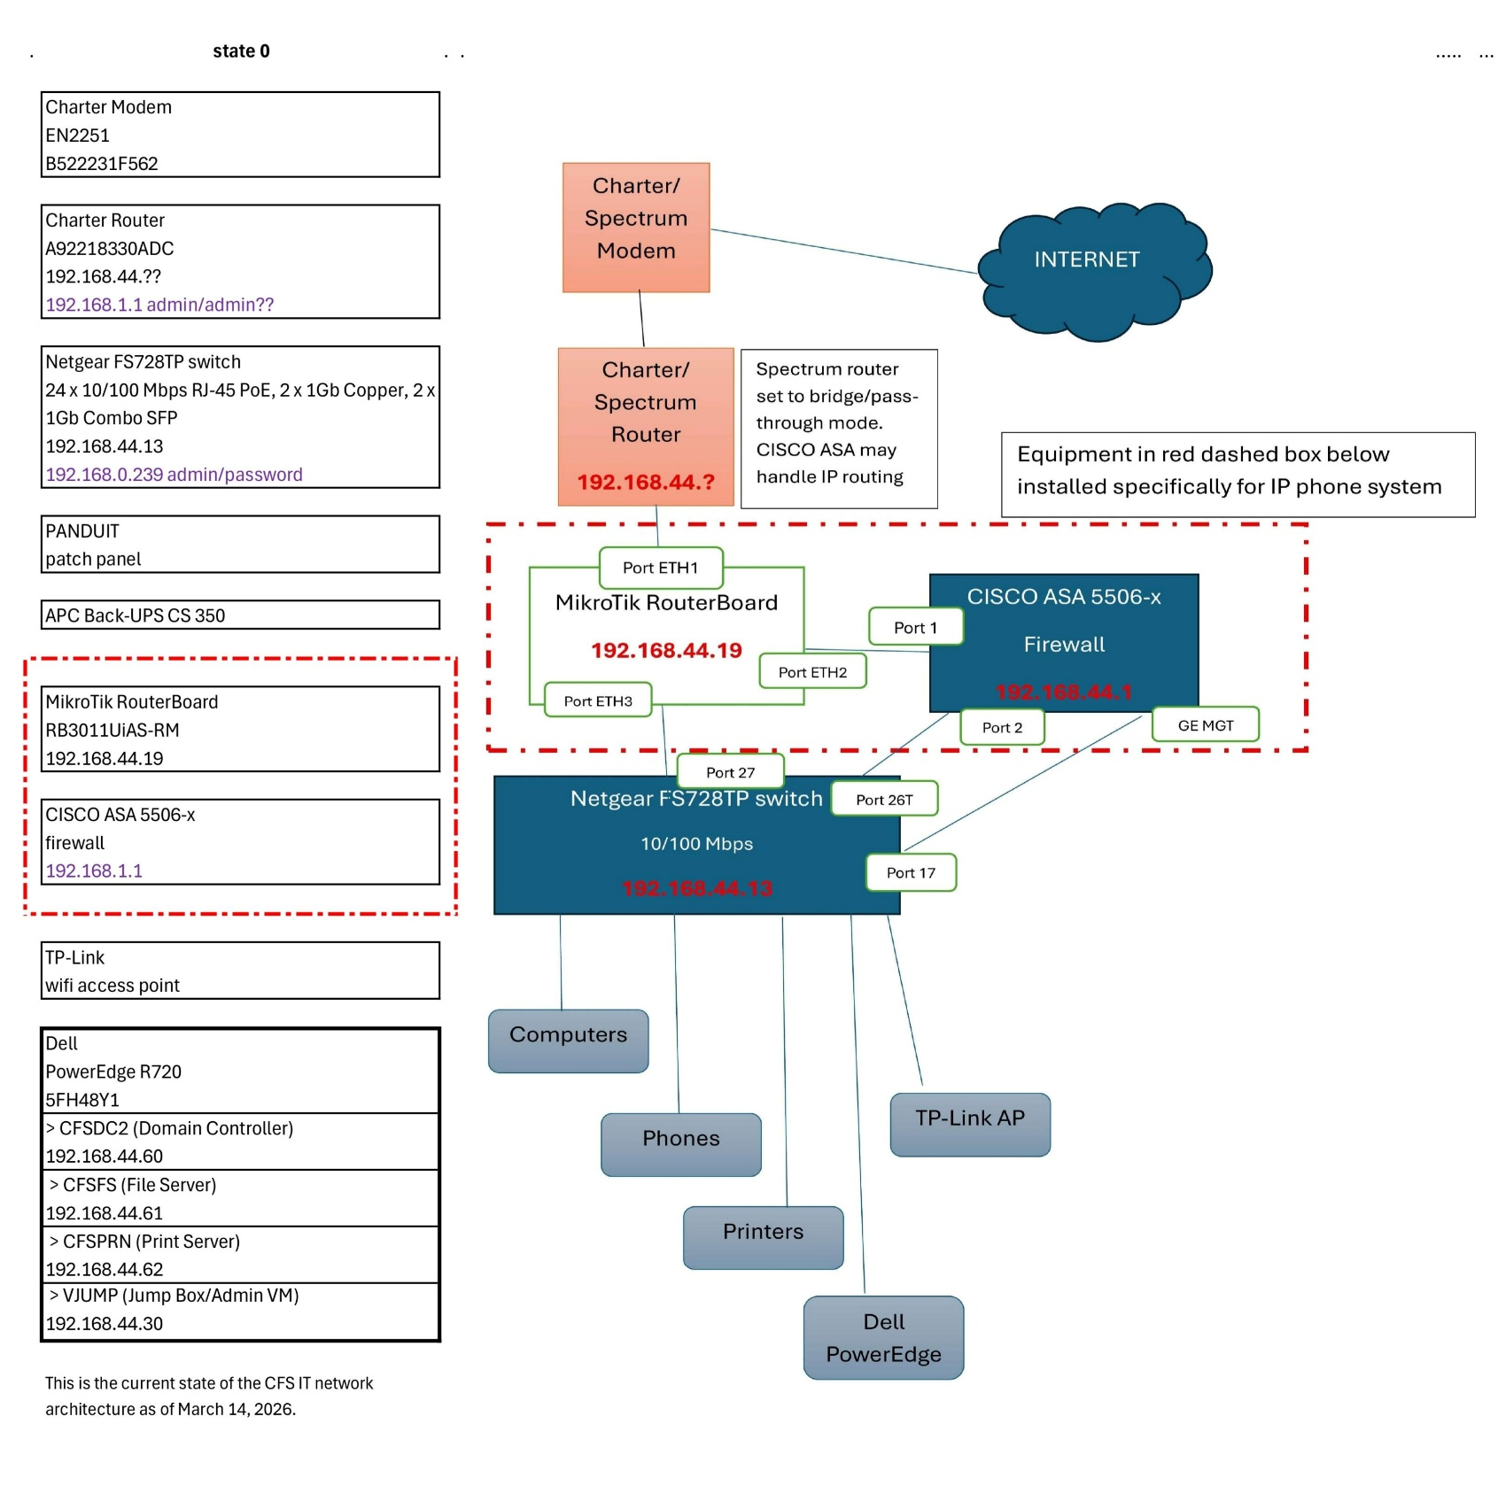

Attachment C
On-line here - https://cfs.mxcoc.xyz/IT/CFS-ITCloset.JPG

CFS 2nd floor IT closet as of March 13, 2026

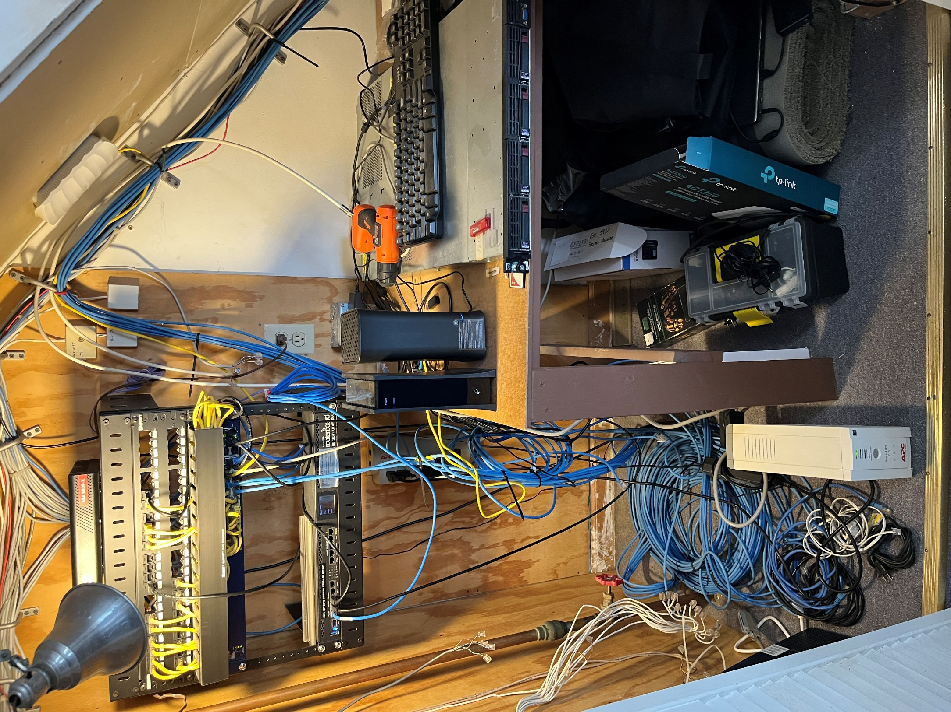

Attachment D.1

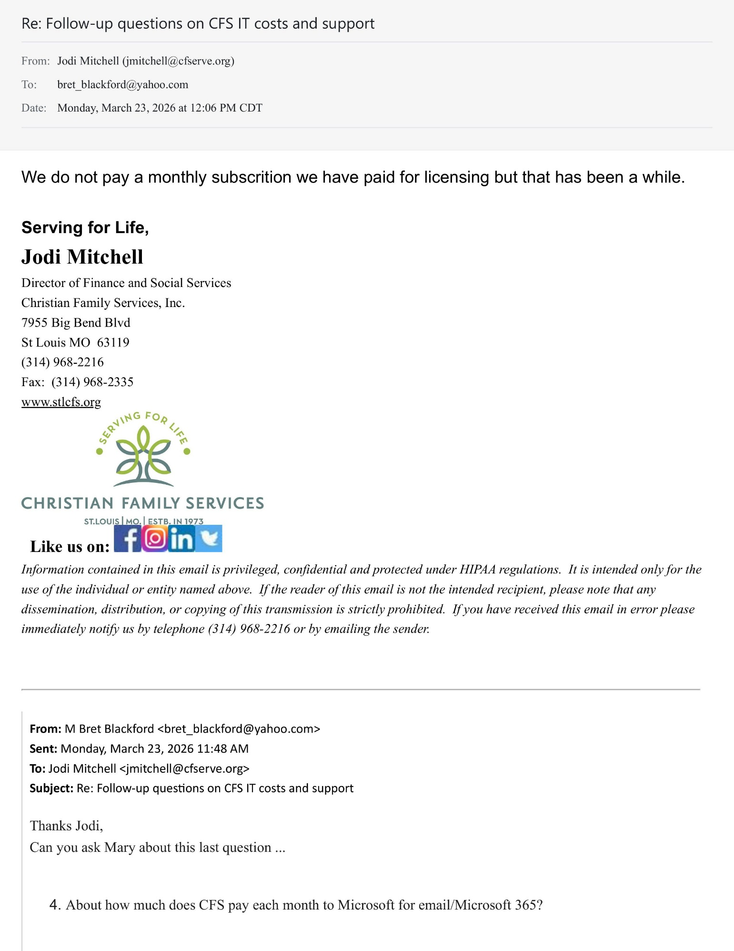

Attachment D.2

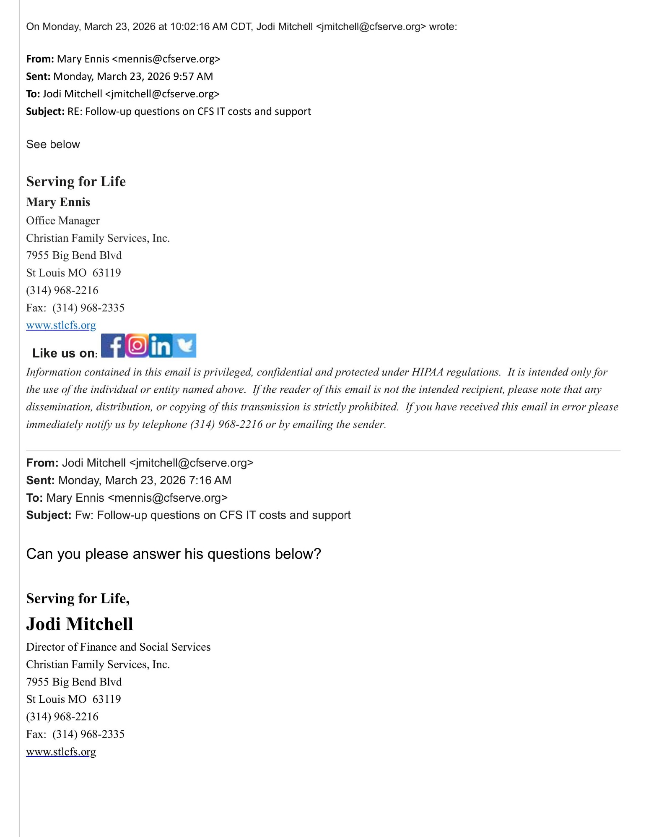

Attachment D.3

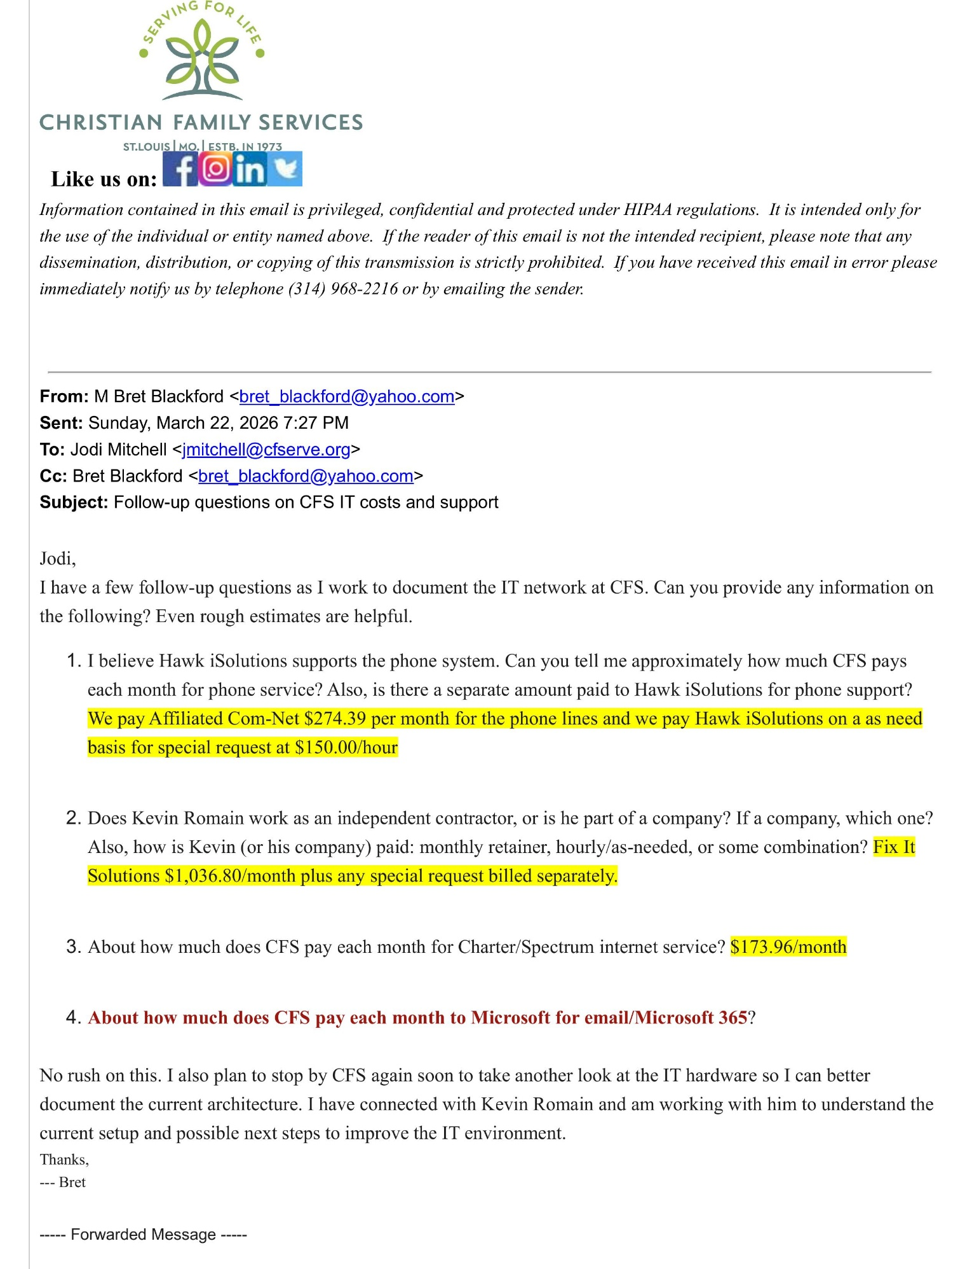

Attachment D.4

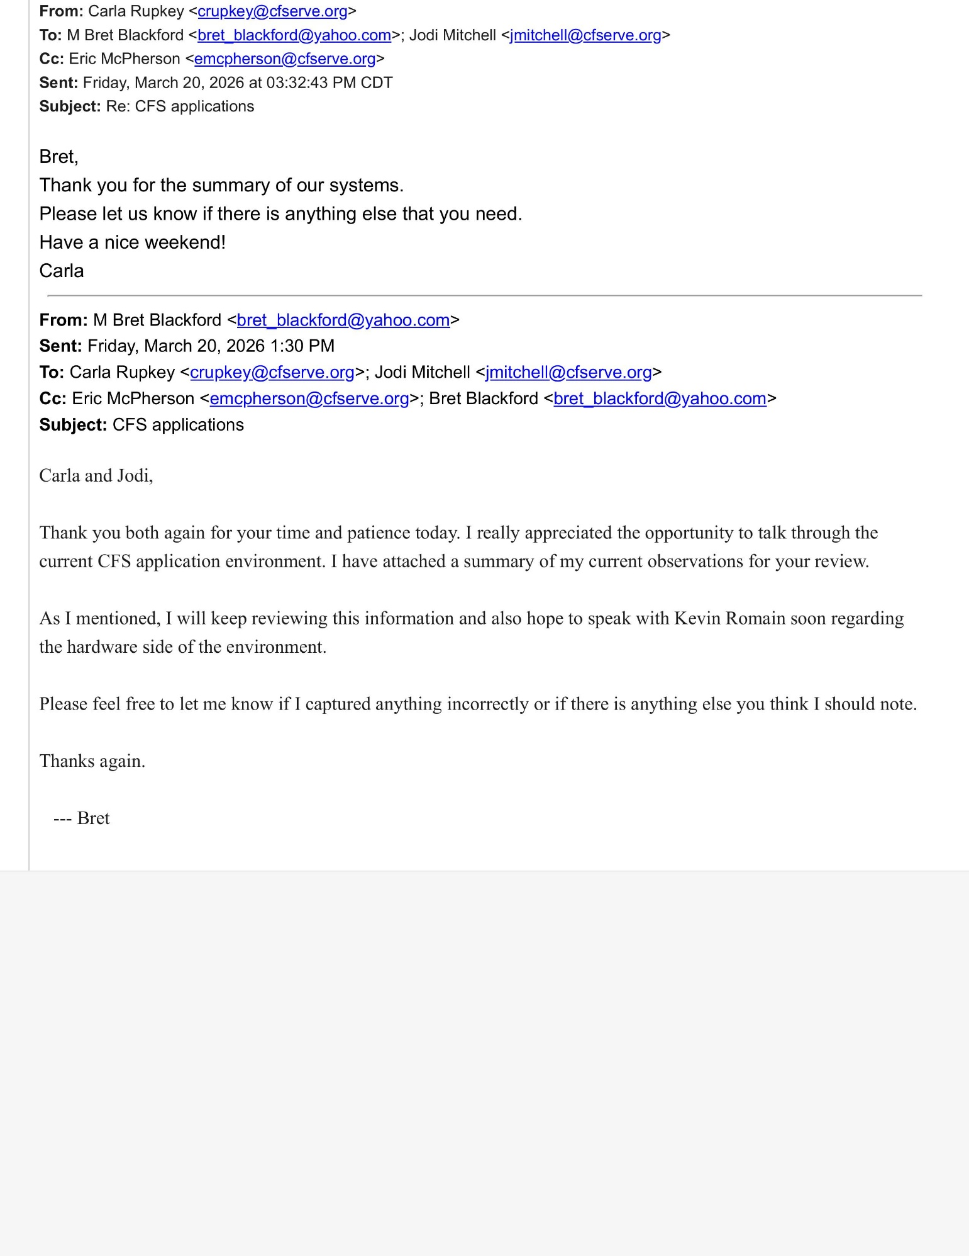

Attachment E.1
Affiliated Com-Net invoice for IP phones @ $274.39/month
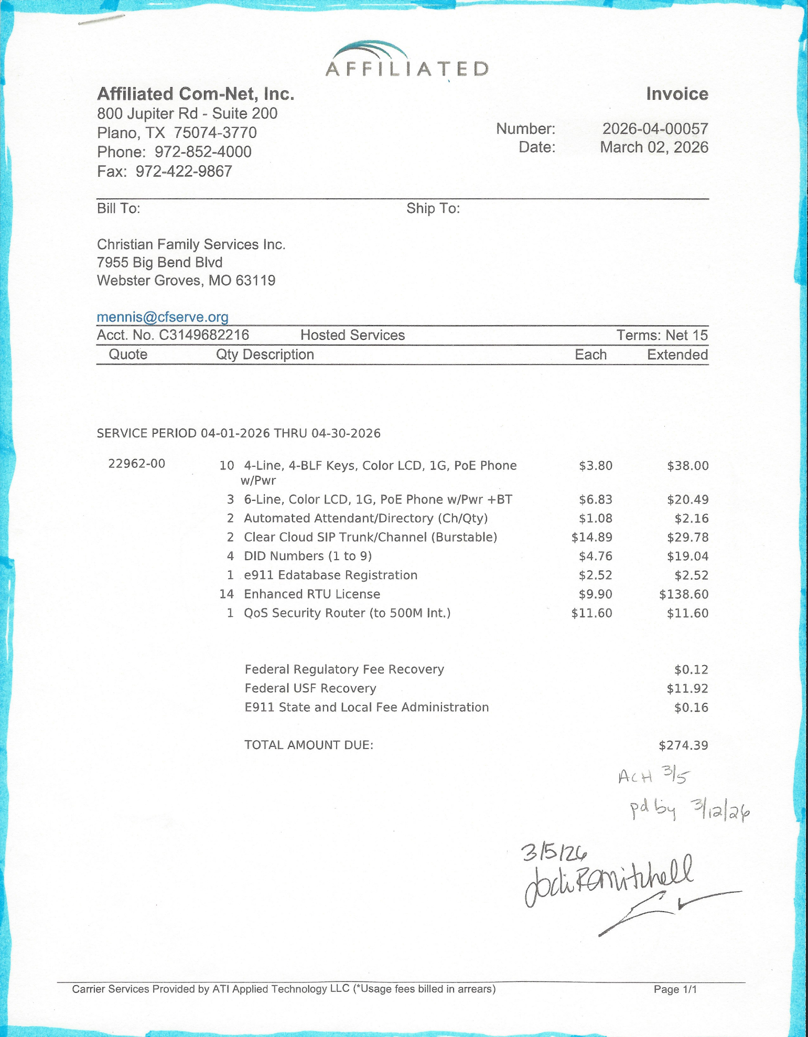

Attachment F.1

The 2024 Managed Services Agreement with Fix It Solutions LLC is included below as an object. Kevin Romain is employed by Fix It Solutions.
Also, on-line here - https://cfs.mxcoc.xyz/IT/Fix%20it%20Solutions%202024.pdf

Attachment F.2
Hawk iSolutions IP phone charges
On-line here - https://cfs.mxcoc.xyz/IT/PHONES_Hawk-iSolutions-2022.pdf

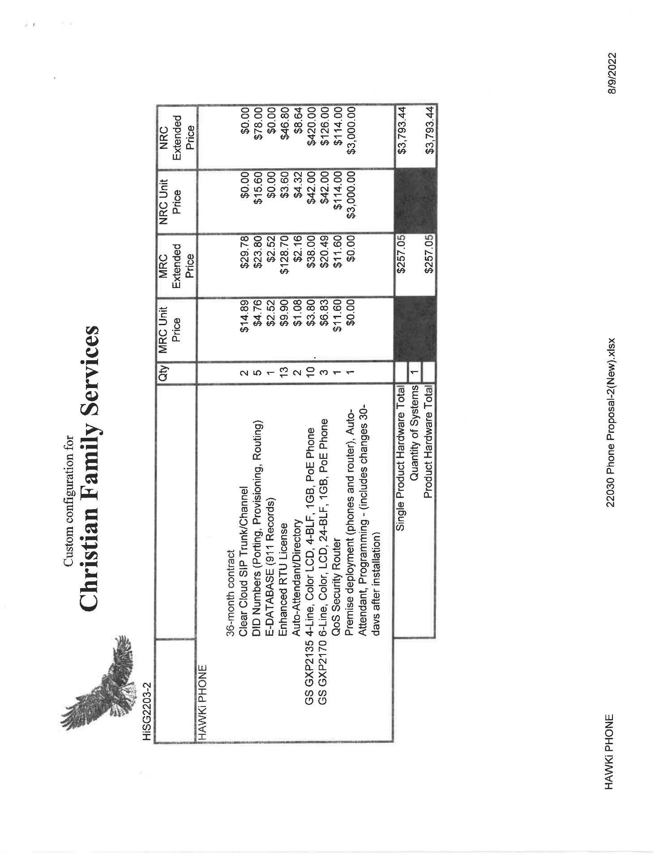

Attachment F.3
Affiliated service agreement for IP Phones
On-line here - https://cfs.mxcoc.xyz/IT/PHONES_Affiliated-2022.pdf

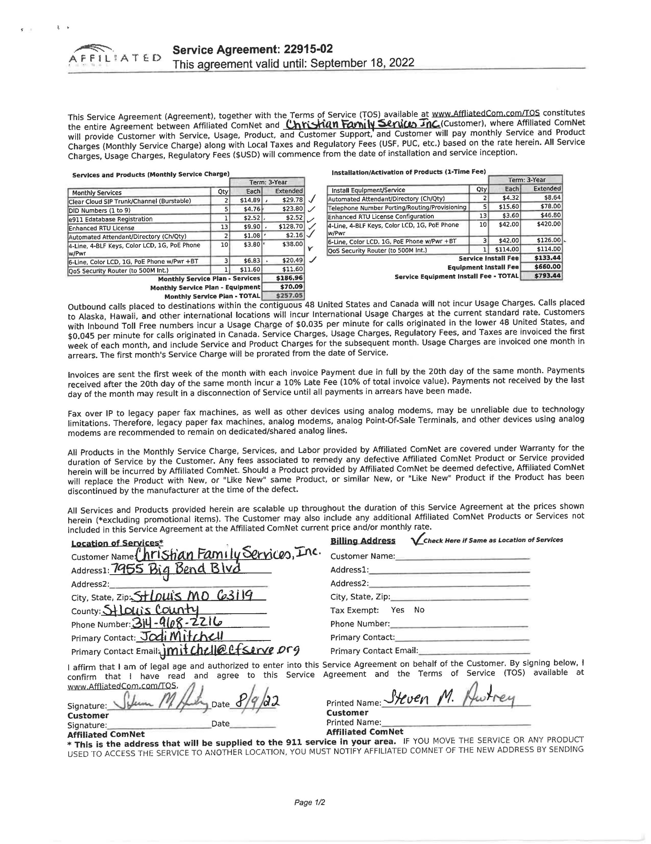

Attachment G

Attached is a recent email between Bret Blackford and Kevin Romain discussing the CFS IT environment. Also, on-line here - https://cfs.mxcoc.xyz/IT/03.23.2026-KevinRomain-email%20-%2003.23.2026.pdf

