CFS IT Closet / Server Rack Work Log – Bret Blackford
Date: April 15, 2026
Location: CFS
Purpose: Track IT closet cleanup, equipment removal, and related network/server rack work performed today so it can be turned into a memo later.

Running Log

Initial status
- Bret is on-site at CFS cleaning up the IT closet, server rack, and related equipment.
- The Cisco firewall has been removed from the closet/rack area.
- The MikroTik RouterBoard has been removed from the closet/rack area.
- The Charter/Spectrum router has been removed from the closet/rack area.
- These removed devices will be retained on-site for several weeks as a precaution in case any item is needed again.
- The Charter/Spectrum router may need to be returned later, so it should be kept identifiable and separate.

Photo comparison added
- A “before” photo from April 13, 2026 and a “today” photo from April 15, 2026 were provided for documentation.
- The photo comparison shows that the rack/closet previously contained additional legacy networking equipment, including the Cisco firewall and MikroTik RouterBoard.
- In the current photo, those legacy devices have been removed from the rack/closet area.
- The rack now appears more open, with less equipment mounted in the lower section.
- The UniFi equipment remains in place on the work surface and appears to be serving as the active setup.
- Cabling is still somewhat temporary/loose in appearance, suggesting cleanup and final cable management may still be in progress.
- The photos will be useful as before/after documentation for the final memo.

Additional work performed
- The TP-Link Omada EAP225 AC1350 access point was removed.
- This removes another piece of legacy network hardware from the IT closet environment.
- With the TP-Link access point removed, the UniFi environment appears to be taking over wireless duties.

Incident / live observation
- During today’s closet work, the Netgear switch was accidentally unplugged.
- Immediate next step is to observe whether any devices, phones, servers, or office connectivity are affected.
- This may help reveal whether the Netgear switch is still carrying active production traffic or whether the newer UniFi switch has effectively taken over those functions.

Phone behavior observed after Netgear unplug event
- After the Netgear switch was accidentally unplugged, Grandstream phones were still rebooting.
- Some phones appeared to indicate that they were updating firmware.
- At this point it is not yet clear whether the phone reboots/firmware messages are directly related to the switch unplug event or part of a separate phone provisioning/update process.
- This should be monitored closely to see whether phones come back normally, register correctly, and can place/receive calls.

Follow-up result after Netgear unplug event
- The phones came back online and are working.
- An outbound call was successfully placed after recovery.
- This is a strong sign that phone service is still functional after the accidental Netgear switch unplug event.
- This may indicate that the Netgear switch is no longer critical for at least some active phone/network traffic, though additional observation is still prudent.

Rack mounting observation
- While preparing the UniFi switch for installation, Bret observed that the included brackets/ears appeared more like wall-mount hardware than traditional 19-inch rack ears.
- Additional confirmation was sought regarding rack-mount options for the UniFi USW Pro Max 16 PoE.
- This may affect how the switch is physically installed in the rack today.

Major migration progress
- Bret moved the UniFi switch into place and populated all 16 available ports.
- Approximately 8 additional Ethernet cables remain active/on the old Netgear switch.
- Based on current port demand, an additional UniFi switch will likely be needed in order to migrate the remaining active connections.
- Once sufficient UniFi port capacity is available and the remaining cables are migrated, the old Netgear switch can likely be decommissioned.
- Today’s work therefore appears to have confirmed that the remaining dependency on the Netgear switch is due to port capacity constraints rather than a clear technical need to retain the older switch architecture.

Materials / follow-up need identified
- Bret determined that at least 6 additional 1-foot UniFi patch cables will be needed to continue/complete the switch migration cleanly.
- This is now one of the identified follow-up material needs from today’s work.

Notes / Observations
- Removed legacy network equipment is being held temporarily rather than discarded.
- This appears to be part of post-cutover cleanup after the UniFi migration.

Possible next step under consideration
- Based on today’s positive results, Bret is considering migrating Ethernet connections from the old Netgear switch to the UniFi switch by unplugging patch cables from the Netgear and reconnecting them to the UniFi switch.
- This step has not yet been confirmed as completed.
- Key risk: the patch panel/cabling is not fully labeled, so port/device identification may require trial and observation.

Physical hardware work in progress
- Bret began physical preparation of the UniFi switch for rack mounting.
- A rack ear was being installed on the left side of the UniFi switch.
- This indicates the UniFi switch is being readied for a more permanent installation in the server rack.

Rack / physical layout change
- Bret removed the Panduit cable management tray from the rack area.
- Current plan is to place the UniFi switch in that location and begin moving Ethernet cables over to the UniFi switch.
- This appears to be a practical interim installation approach given the rack-mount hardware question for the USW Pro Max 16 PoE.

Switch handling before cable migration
- Bret had to temporarily unplug the switch during today’s work.
- The switch was then plugged back in.
- Bret is now preparing to begin moving Ethernet (CAT) cables from the Netgear switch over to the UniFi switch, particularly the patch panel connections.
- This appears to be the start of the active switch migration phase.

Items to capture as work continues
- Additional equipment removed, relocated, or labeled
- Any changes to cabling, patch panel connections, or switch placement
- Any testing performed after cleanup
- Any issues found or risks noted
- Final condition of the IT closet and rack
- Any follow-up items or deferred work

Draft Memo

CFS IT Closet / Network Equipment Work Performed — April 15, 2026
On April 15, 2026, work was performed at CFS to continue cleanup and simplification of the IT closet/server rack area following the recent UniFi migration efforts. The primary objective was to remove no-longer-needed legacy network equipment from the closet/rack area, improve the physical layout, and continue migration from the older Netgear switch to the newer UniFi switch environment.
Several legacy devices were removed from the IT closet/server rack area, including the Cisco firewall, MikroTik RouterBoard, Charter/Spectrum router, and TP-Link Omada EAP225 AC1350 access point. These items were not discarded. Instead, they were intentionally retained on-site for several weeks in case any of them are needed again during the stabilization period. The Charter/Spectrum router should remain identifiable and separate, as it may need to be returned later.
Before-and-after photos were also captured/documented. These photos show that the rack previously contained additional legacy networking hardware and now has a cleaner, more open layout, especially in the lower rack area. The UniFi environment now appears to be the primary active platform.
During the day’s work, the old Netgear switch was accidentally unplugged. This created an unplanned but useful live test. Grandstream phones were observed rebooting, and some appeared to be updating firmware. However, the phones subsequently returned to service and an outbound call was successfully placed. This was an important result, as it strongly suggests that the old Netgear switch is no longer critical for at least current phone operations, though continued observation remains prudent.
Additional physical rack work was also attempted in preparation for a more permanent installation of the UniFi switch. While beginning installation work, it was observed that the included mounting hardware for the UniFi USW Pro Max 16 PoE appeared better suited for wall/compact mounting than for direct 19-inch rack mounting. As a practical interim measure, the Panduit cable management tray was removed so that the UniFi switch could be placed in that location and used operationally.
Later in the day, the UniFi switch was moved into position and the active migration of Ethernet connections began. CAT cables were moved from the old Netgear switch to the UniFi switch. By the end of the work session, all 16 ports on the UniFi switch had been populated. Approximately 8 additional Ethernet cables still remain active on the older Netgear switch. Based on this result, the remaining dependency on the Netgear switch appears to be primarily a matter of insufficient port capacity rather than a technical need to preserve the older switching design.
At this point, an additional UniFi switch will likely be needed in order to migrate the remaining active Ethernet connections and fully decommission the old Netgear switch. In addition, at least 6 more 1-foot UniFi patch cables will be needed to continue/complete the migration cleanly.

Summary of Key Results
- Legacy equipment removed from closet/rack area: Cisco firewall, MikroTik RouterBoard, Charter/Spectrum router, and TP-Link Omada EAP225 AC1350.
- Removed equipment retained on-site temporarily for contingency and possible return needs.
- Before/after photos documented the closet/rack cleanup progress.
- Accidental Netgear switch unplug served as a useful live test.
- Grandstream phones recovered successfully and outbound calling worked.
- UniFi switch was physically moved into place and fully populated with 16 active ports.
- About 8 active Ethernet connections still remain on the old Netgear switch.
- Main remaining obstacle to full Netgear decommissioning appears to be lack of sufficient UniFi port capacity.

Follow-Up Items / Next Steps
- Continue monitoring production stability after today’s changes.
- Obtain an additional UniFi switch to handle the remaining active Ethernet connections.
- Obtain at least 6 additional 1-foot UniFi patch cables.
- After additional switch capacity is available, migrate the remaining active Netgear connections.
- Once migration is complete and stable, decommission and remove the old Netgear switch.

Added Attachment Recommendations and Embedded Exhibits
To ensure this report can stand alone and contain the supporting visuals referenced in the narrative above, the recommended images and screenshots have been embedded below as part of this document.
Attachment 1 is the primary photo exhibit and is the most useful visual for the main body of the memo because it documents the physical cleanup, equipment removal, and progression of the closet/rack work by step.
Attachment 2 is included as a supporting technical exhibit because it helps document connected devices/client visibility in the UniFi environment after the migration work and after the Netgear unplug event.
Attachment 3 is included as a supporting technical exhibit because it helps document switch port usage, port population, and the remaining port-capacity constraints discussed in the work log and draft memo.
For a stand-alone version of this report, all three exhibits are included below so that the report contains the data, information, pictures, and attachments needed to support the written narrative.

Attachment 1 — IT Closet Step Photo Collage
Primary visual exhibit for the memo. This collage shows the step-by-step progression of the IT closet/rack work and is the best single image for documenting cleanup progress, removal of legacy equipment, and the still-temporary cable state.
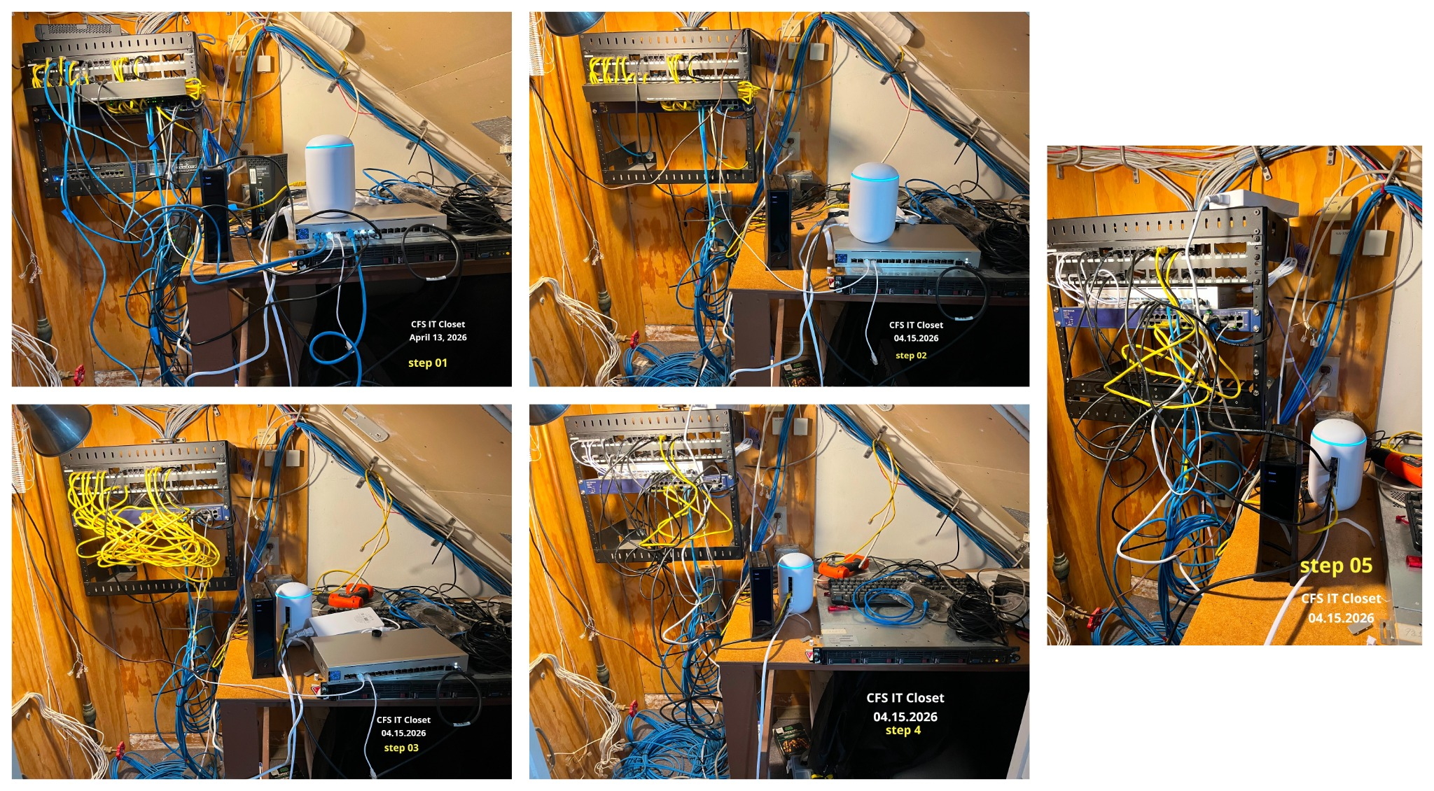
Attachment 1 — IT Closet Step Photo Collage

Attachment 2 — UniFi Clients / Connected Devices Screenshot
Supporting technical exhibit. This screenshot helps document that the UniFi environment was seeing connected devices/clients after the work and is useful for supporting the observations about post-change monitoring and continued production visibility.
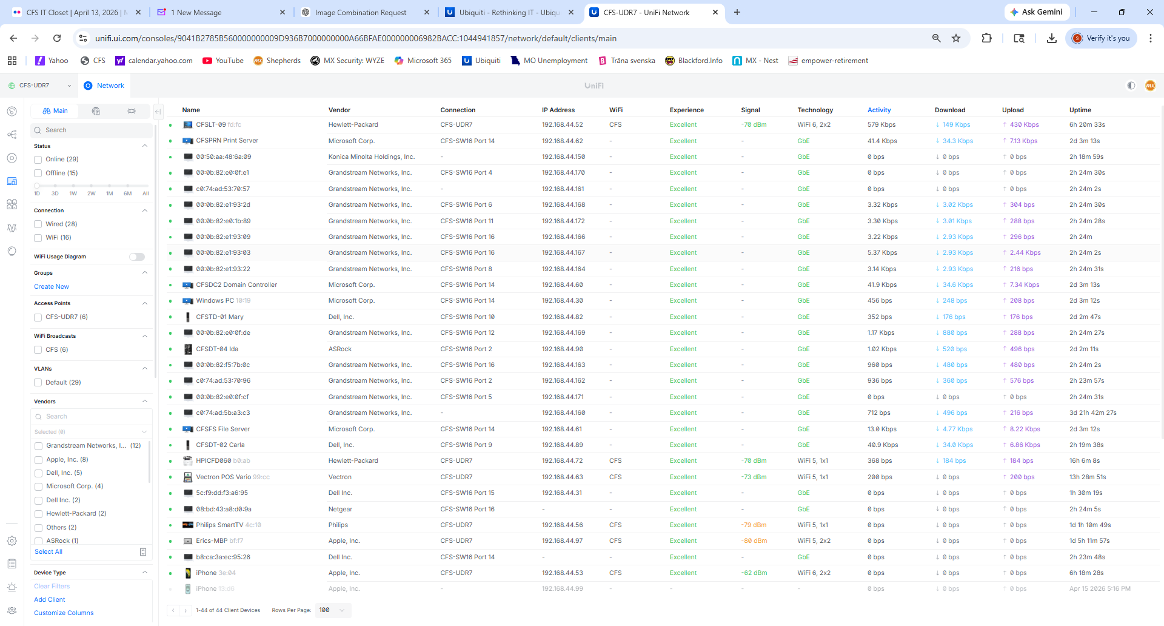
Attachment 2 — UniFi Clients / Connected Devices Screenshot

Attachment 3 — UniFi Ports / Switch Population Screenshot
Supporting technical exhibit. This screenshot helps document switch port population and remaining port-capacity constraints, which supports the notes that the UniFi switch was filled and that some additional active connections remained to be addressed.
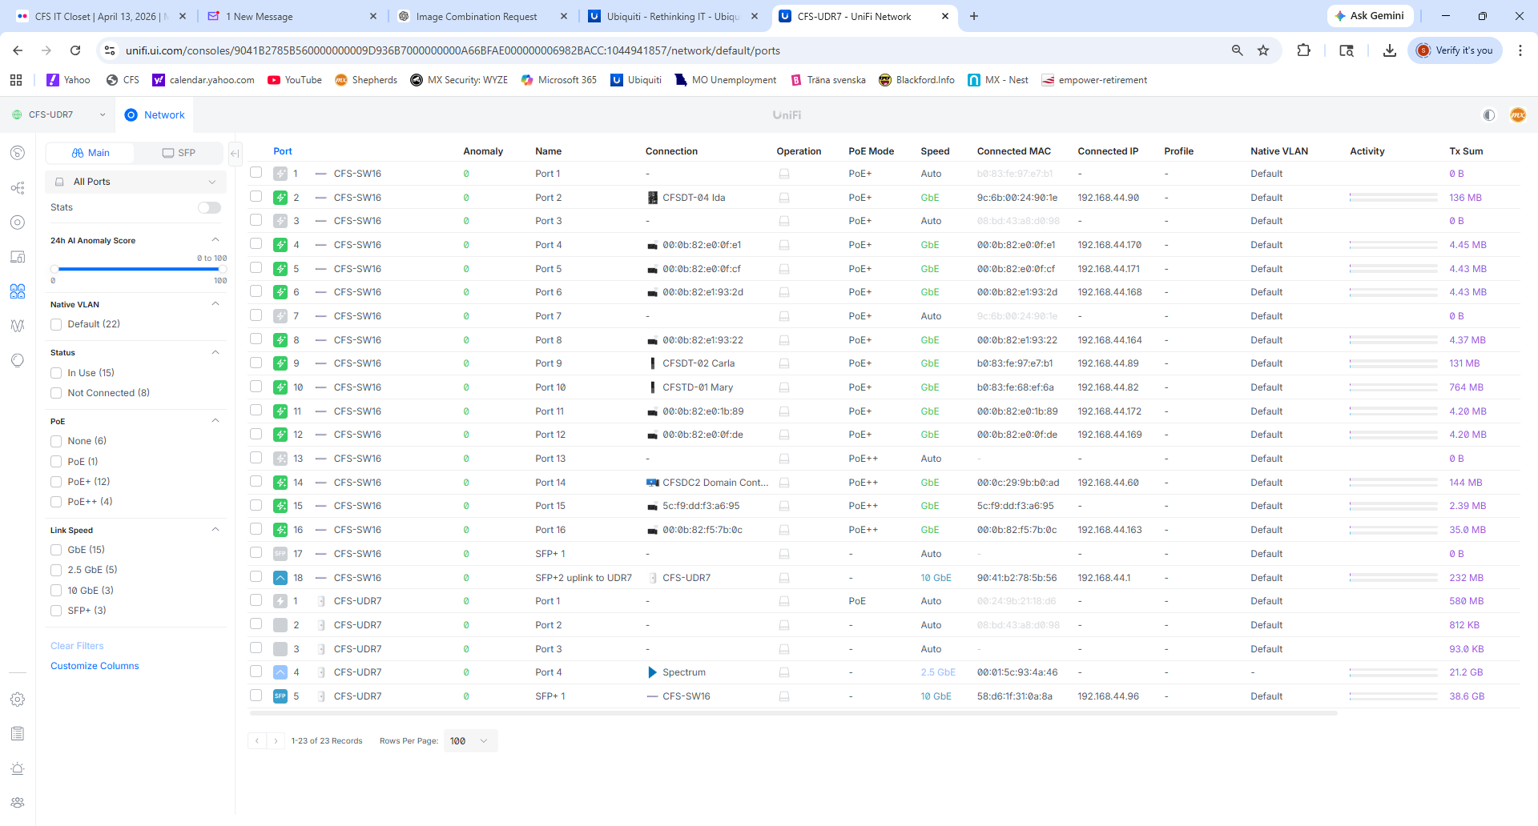
Attachment 3 — UniFi Ports / Switch Population Screenshot

